Khoa Tran

10/18/18

CSE 142 BK

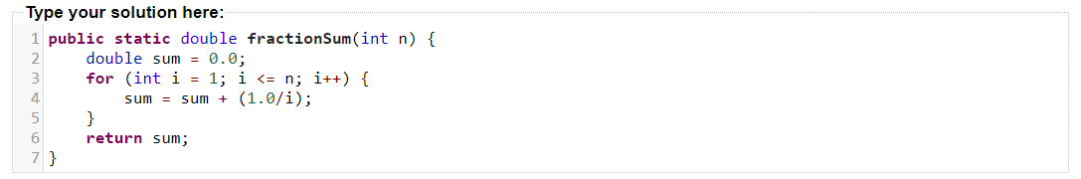Programming Exercise 4.1

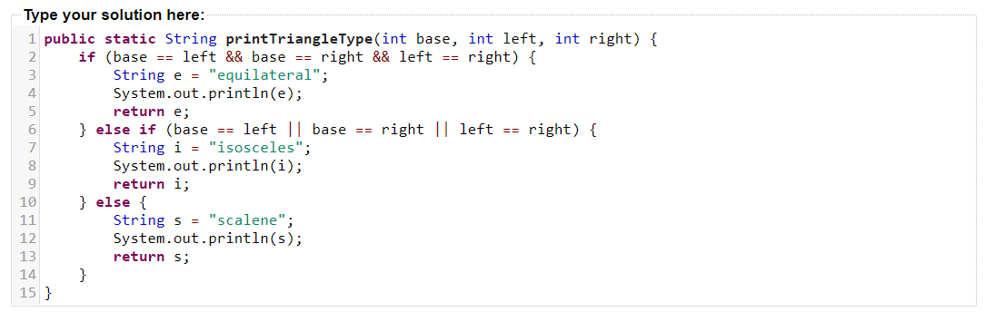Programming Exercise 4.2